FROM: Clerk of the Budleigh Salterton Town Council

TO: Returning Officer, East Devon District Council,
Blackdown House, Border Road, Heathpark Industrial Estate, Honiton, Devon, EX14 1EJ

1. I HEREBY GIVE YOU NOTICE that a casual vacancy exists in the office of Town Councillor on the Town Council of the Town of Budleigh Salterton
on the resignation of Lesley Miszewska

2. Public Notice of the said vacancy was published by me on the 23rd March 2026

3. The casual vacancy occurred on the 17th March 2026
DATED this 20th day of March 2026

SIGNED 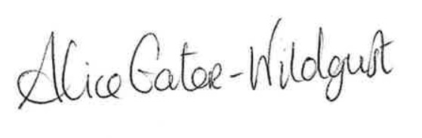 Name Alice Gater-Wildgust
Town Clerk
Budleigh Salterton Town Council
Council Offices, Station Road
Budleigh Salterton EX9 6RJ

NOTE: This form must be sent to the District Council as soon as the public notice is published.

Form CVP2

