THE NORMAN CENTRE
Station Road, Budleigh Salterton

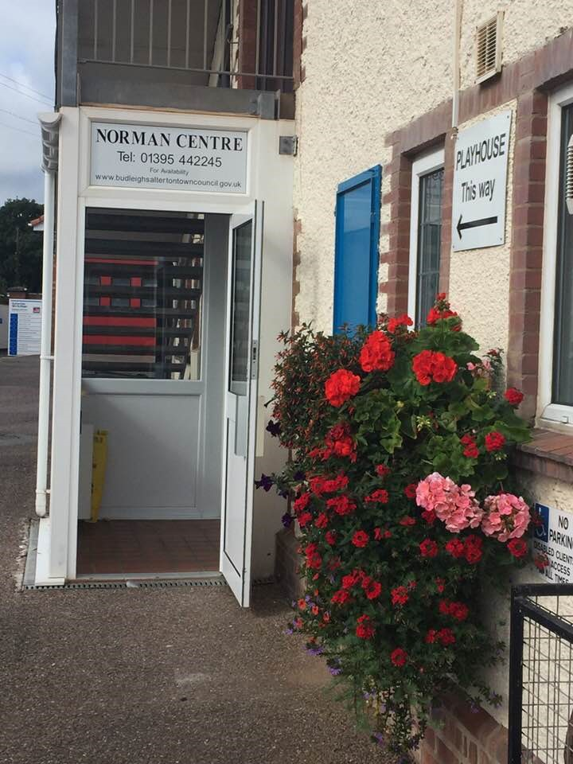

Adjacent to the Public Hall, the Norman Centre is the ideal venue for small group activities, committee meetings, family celebration events.

- The main area will seat around 20 people but can also be used as an open space
- Disabled toilet facilities
- Newly installed kitchen
- Wi-fi enabled
- Adjacent to public car parks
- Hire costs currently £10.00 an hour (minimum rental period 2 Hours)
- Commercial hire rates on application

To view the Centre or make booking enquiries, please contact the Town Council Offices:

T: 01395 442245
E: office@budleighsaltertontowncouncil.gov.uk
W: www.budleighsaltertontowncouncil.gov.uk

